Final Project Report

Finding Optimum Parameters for

Pulsed LED Operation

IEE 572 Design of Engineering Experiments  
Prof. Douglas Montgomery

Team:

Gabriel Anzziani (gabriel.anzziani@asu.edu)

Christi Lemon (cllemmon@asu.edu)

Janine White (jiwhite@asu.edu)



**Background**

Today’s embedded systems are characterized by consuming very low power. This is particularly true in battery powered systems, so the system can operate for as long as possible. There is extensive use of LEDs in embedded systems, so it only makes sense to find ways to optimize the energy used to drive the LED while maintaining the same visible output.

1. **Recognition and Statement of the problem**

The most common way to drive an LED is with DC operation (using constant current). An alternative to DC operation is to use pulse width modulation (PWM) to drive the LED while applying a higher current. There is contradicting informationabout whether this method is more efficient because as the duty cycle increases, peak current drops. Some claim that the LED itself will be less efficient at higher currents [1], while others claim that the human eye will perceive an increased intensity with PWM [2][3]. We will conduct our own experiment to verify if PWM is better to drive an LED. Our goal is to obtain the same light intensity from PWM compared to a fixed DC current, while reducing the power required.

1. **Choice of Factors, Levels and Ranges.**

The following are the factors that we believe will have an effect on the experiment:

- **Frequency**: We want to avoid visible flickering, so the minimum frequency will be 100Hz, and the maximum will be 3 kHz, limited by the capabilities of the instrument we are using.

- **Duty Cycle**: This parameter can vary from 0.39% to 99.61%. But it will be of little value to use a duty cycle above 20%, since we are studying the effect of small pulses. With testing 1.171% was found to be the lowest useful Duty Cycle.

- **Offset:** An offset of 0mA means that the LED is completely shut off between pulses. We can also apply a small current offset to determine if this has an effect on the LED efficiency.

We used four levels for each factor:

**Table1. Parameters**

|  |  |  |  |  |
| --- | --- | --- | --- | --- |
| **Factor** | **Low Level** | **Mid Low Level** | **Mid High Level** | **High Level** |
| Frequency (Hz) | 62.5 | 250 | 625 | 2500 |
| Duty Cycle (%) | 1.172 | 5 | 10 | 20 |
| Offset (mA) | 0 | Base by Device | Base + 1 level | Base + 2 levels |

Other parameters that could affect the experiment, which we will keep constant:

- **Temperature**: One of the consequences of using higher currents is that the temperature of the LED will increase, and could lead to thermal damage.

- **Type of LED**: We will focus on only one type of LED: LP3341 from Siemens.

- **Batch to batch variation**: All the LEDs we are using came from the same batch.

1. **Selection of the response variable**

As stated on section 1, we want to obtain the same amount of apparent light, while minimizing the power. For each test, each team member will compare the reference current with the experiment current, and gradually increase the amplitude of the pulse until the brightness appears the same. The desired response variable is the power required to obtain the same apparent brightness as the 1.85mA reference, however it cannot be measured directly. Instead, Peak Current was measured in each run of the experiment.

**Power** = Voltage x Current = 5V x Average Current of the experiment where

Average Current = (100 - Duty Cycle)*(Offset Current) + (Duty Cycle)*(Peak Current)

Figure 1 shows our experiment setup. All the parameters will be adjusted with the Xprotolab device, which is an oscilloscope with an integrated arbitrary waveform generator (AWG). A switch will be used to change the current to the LED, from the reference current, to the experiment current. This way, the observer can easily determine which setting is brighter.

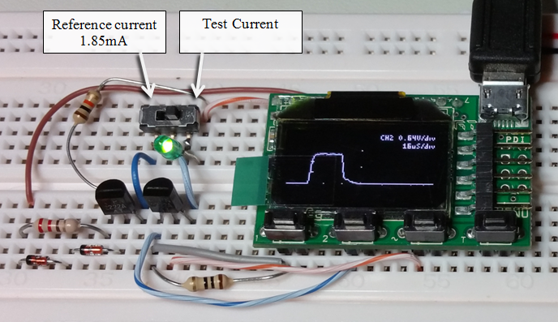

**Figure 1: Experiment Set Up**

Figure 2 shows the experiment schematic. On the left we have the constant current driver, set at 1.85 mA. On the right we have a similar current driver, but it is driven by the Xprotolab’s AWG.

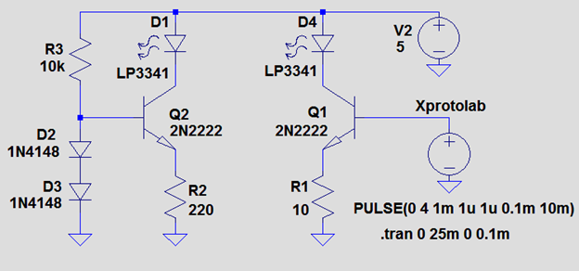

**Figure 2: LED Driver Circuit**

Figure 3 shows a SPICE simulation example of the experiment. The blue line is the reference current (1.85 mA), the green line is the experiment current (PWM with high current).

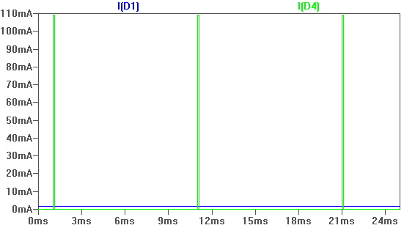

**Figure 3: Spice Simulation Example**

**Methodology**

Oscilloscope devices were mailed to each participant in the group. We met online to finalize the configuration of the device and verify functionality. An experimental design was created to account for the 3 factors, frequency, duty cycle, and offset, with 4 levels each blocked by group member/device. Each project member completed all 64 runs on their device in random order as using the Gabatronics software.

First, offset levels were determined for each device using the following procedure.

1. Set Oscilloscope> Free
2. Set Waveform Generator
   1. Amplitude = 0
   2. Offset = 0
   3. Frequency per experiment
   4. Duty Cycle per experiment
3. Switch to experiment current, then increase Offset until some light is visible
4. On Meter, note Channel 1 voltage = Level 1
5. Increase Offset 1 level on Waveform Generator
6. On Meter, note Channel 1 voltage = Level 2
7. Increase Offset 1 level on Waveform Generator
8. On Meter, note Channel 1 voltage = Level 3

Each run of the experiment was performed using the following procedure.

1. Switch from reference to experiment current
2. Set Oscilloscope>Type Free
3. Set Amplitude to 0
4. Set Offset per experiment
5. On Meter, read and note VPP as Offset Current
6. Set Frequency, and Duty Cycle per experiment
7. Increase Amplitude until experiment current brightness matches reference brightness
8. Set Oscilloscope>Type>Auto
9. Adjust Gain as high as possible without clipping
10. Use CH1 for measurements unless clipping.
11. CH1
    1. Set Options>Automatic CH1
12. CH2
    1. Set CH1 Gain to 0
    2. Set Options>Cursors> Automatic CH2
    3. Adjust CH2 Gain as high as possible without clipping
13. Note Peak Current - Vb for CH1 or Vb*100 for CH2

The data collected is in the following file.



**Results**

The factors explored in this experiment were Device, Frequency, Duty Cycle, and Offset and the primary response variable was Peak Current. Peak Current had a logarithmic distribution. Log(Peak Current) was used in the analysis to create a more normal distribution.

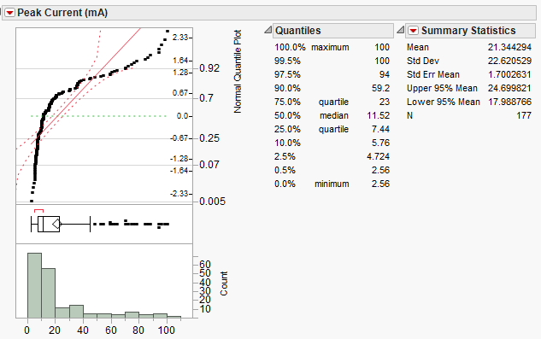

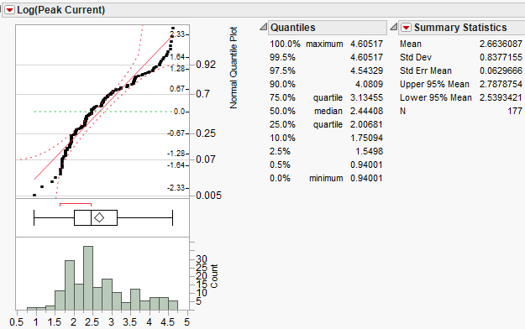

Fitting Peak Current by Frequency and Duty Cycle, Frequency affects Peak Current below 2500 Hz about the same at all measured frequencies, while 2500 is significantly lower. Frequency was recoded to <2500 (-1) and 2500 (1) for analysis. Future experiments could explore the frequency distribution further to find where the relationship changes. Duty Cycle is not linearly related to Peak Current, requiring the introduction of a Duty Cycle Squared term in the analysis.

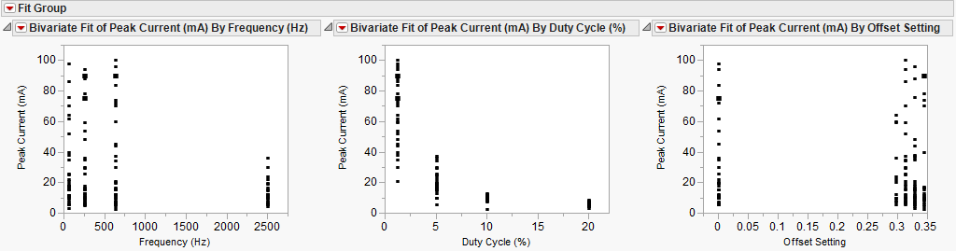

Looking at the Fit of Device, Frequency Recode and Duty Cycle Recode by Log (Peak Current), there are 6 outliers, 3 on Device 2 and 3 in Duty Cycle. These were all from Janine’s device. Because the device was significantly different that the other two and it had difficulty completing the last few runs due to a loose switch, it was removed from the final analysis and the devices were recoded to Gabriel = -1, Christy = 1. Tests show that the means and the variances of Peak Current are not significantly different between these devices. The Offset is similarly not significantly different in means or variance. Duty Cycle means and variance are significantly different.

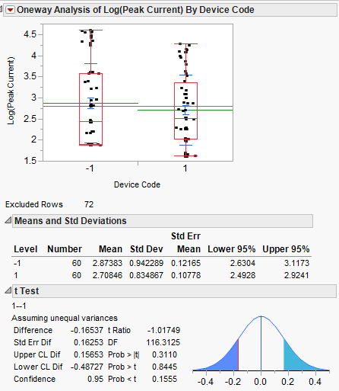 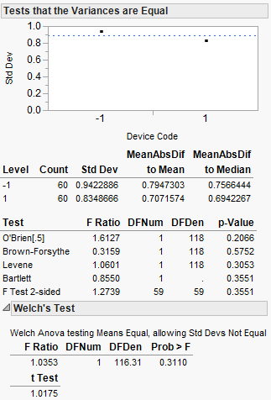

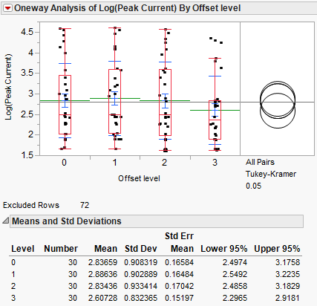

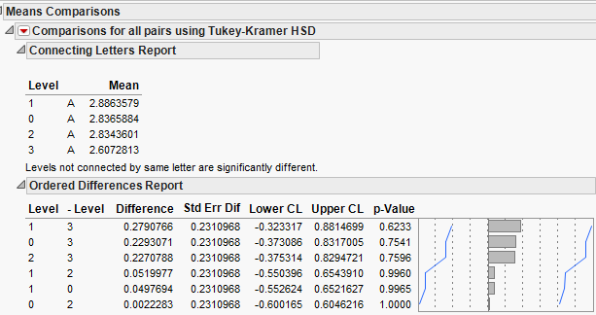

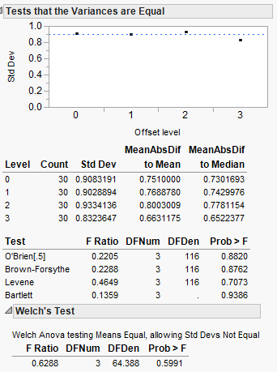

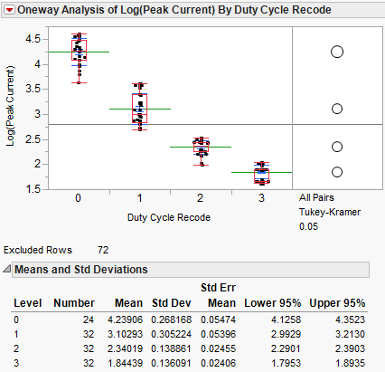

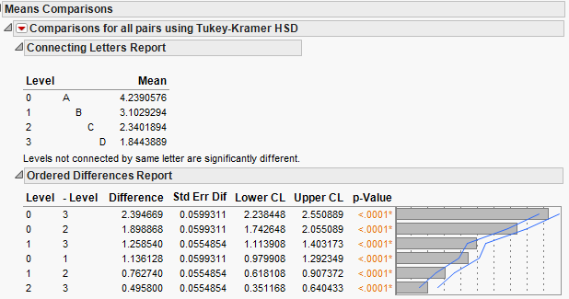

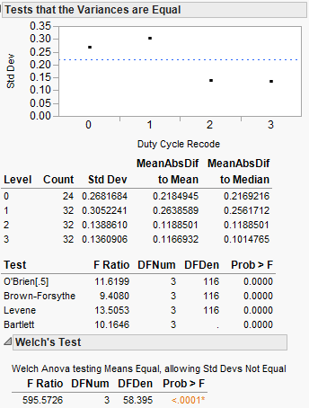

Running a full factorial model, Duty Cycle, it’s square and it’s interaction with Device are significant with an RSquare of 95%. The residuals appear randomly distributed.

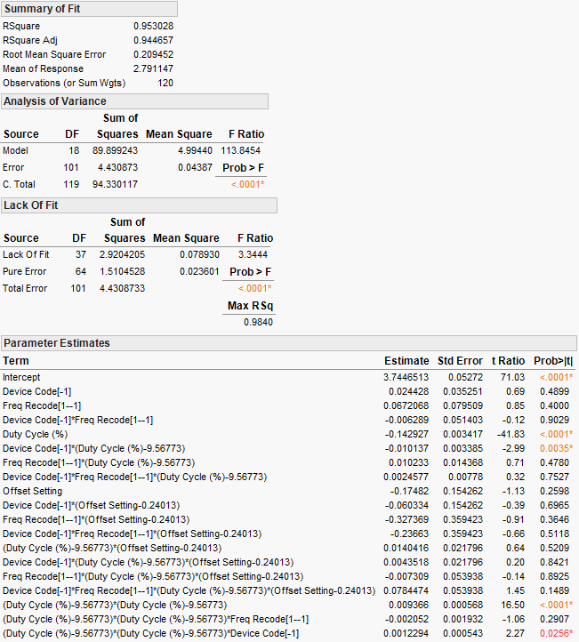

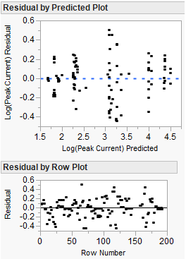

The model with terms that are not significant removed is shown below.

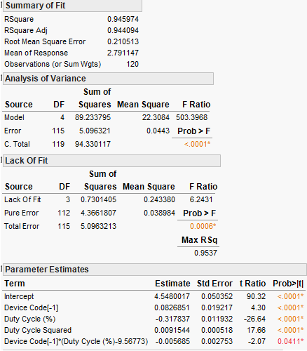

The predictive equation of the stripped down model is:

$$\log\left(\hat{y}\right)=4.548+0.0827\left(Device\right)-0.318\left(Duty Cycle\right)+0.009\left({Duty Cycle}^{2}\right)-0.003\left(Device x Duty Cycle\right)$$

$$\hat{y}=94.4433e^{0.0827\left(Device\right)-0.318\left(Duty Cycle\right)+0.009\left({Duty Cycle}^{2}\right)-0.003\left(Device x Duty Cycle\right)}$$

Figure 4, below, shows the plot of the predicted value of peak current.

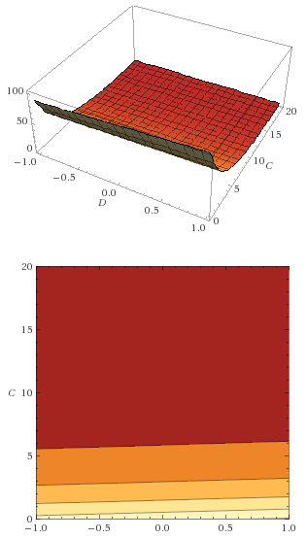

**Figure 4: Predicted Peak Current**

**Conclusion**

Peak Current is minimized by increasing the Duty Cycle.  Future experiments could test the region between 6% and 8% for optimal Duty Cycle, or it could be optimized near 6% Duty Cycle based on other criteria for the functioning of the LED in a specific device. The Device contribution is significant, but some variation is expected given the prototype nature of the devices we were using. If they were standardized in a product, the Device and Device-Duty Cycle interaction would probably be negligible or manageable in production.

**References**

1. Russell McMahon. Stack Overflow - Does pulsing an LED at higher current yield greater apparent brightness?
2. Jinno, Masafumi; Morita, Keiji; Tomita, Yudai; Toda, Yukinobu; Motomura, Hideki . JOURNAL OF LIGHT & VISUAL ENVIRONMENT · JANUARY 2008 - Effective Illuminance Improvement of a Light Source by Using Pulse Modulation and Its Psychophysical Effect on the Human Eye
3. Naoshige Shimizu. Human Perception Studied to Double LED Brightness
4. Siemens LP3341 Datasheet